DESCON **DESCON ENGINEERING**

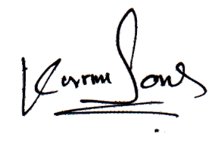

Descon World Headquarter LAHORE 53000-PAKISTAN

P.O. Box No. 1201 18 KM Ferozepur Road Lahore. Tel: (042) 5990034, UAN: 111 DESCON. Fax 5811135

### SERVICE CERTIFICATE

**Certified that Mr. <Name> Emp. No. 571652 H.O. NO. NIL S/O <fname> Nationality Pakistani**

**has worked as <Designation> at our: Nishtar‑II Hospital Project**

**From: <From> to <To> (SPORADICALLY / INTERMINTANTLY)**

He left the job on his accord His services were terminated because of

His services were no more required He was relieved of the job ion the completion of contract / job assigned / project.

DESCON

**M**

**HAMID MEHMOOD KHAN PROJECT MANAGER**